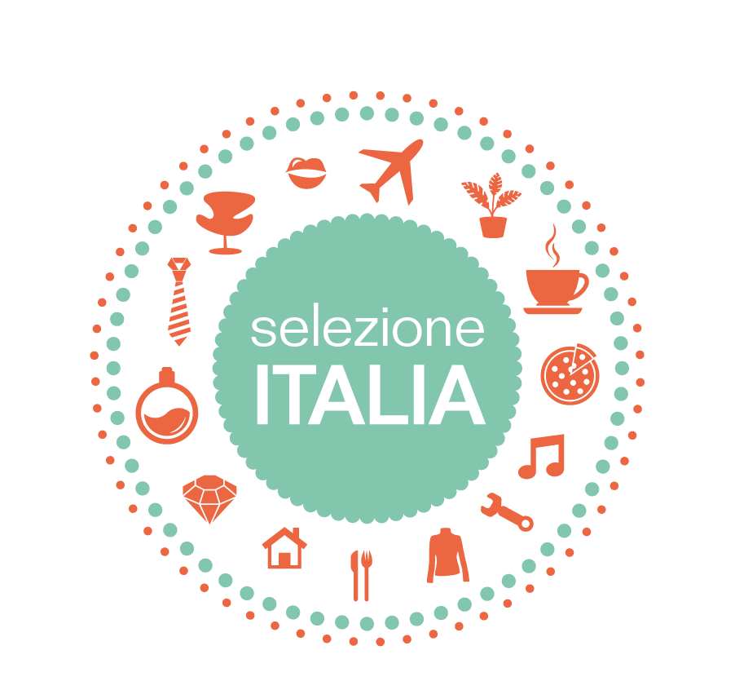

**SELEZIONE ITALIA by CLASSIC WINE EVENTS**

**TALLINN, Park Inn Meriton Conference&SPA**

**29th of October 13.00-17.00**

presented by CIBUS ET PROSIT

CANTINA MICHELI - AZIENDA AGRICOLA MICHELI FRANCESCO (Trentino A.A.)

www.cantinamicheli.it

AZIENDA AGRICOLA MONTE BRECALE DI SINIGAGLIA MATTEO (Veneto)

www.montebrecale.it

AZIENDA AGRICOLA MONTE SANTOCCIO DI FERRARI NICOLA (Veneto)

www.montesantoccio.it

EURAL SULCIS SOCIETÀ AGRICOLA S.R.L (Sardinia)

www.euralsulcis.it

CANTINE SAN MARCO (Latium)

www.sanmarcofrascati.it

CASTELLO DI GRUMELLO (Lombardy)

www.castellodigrumello.it

BIRRA CALA (Calabria)

Beers: Lager, IPAs

www.birracala.it

Presented by ORBICO ADRIATIC WINES   
KLET BRDA (SLOVENIA) - https://klet-brda.si/en/  
KOBAL WINERY (SLOVENIA) - https://www.kobalwines.si/domov/?lang=en  
DOMAINE SLAPSAK - https://www.domaine-slapsak.com (SLOVENIA)

GIACOMO BARBERO (Piedmont)

www.giacomobarbero.it

presented by ITC WINE

PIANDIMARE (Abruzzo)

www.piandimare.it

TENUTA LA PRESA (Veneto)

www.tenutalapresa.it

POGGIO PINARO (Tuscany)

www.poggiopinaro.com

presented by CM WINE VISION

CAGLIERO (Piedmont)

https://cagliero.com/it/home

CHIORRI (Umbria)

www.chiorri.it

SAN LORENZO (Abruzzo)

www.sanlorenzovini.shop

CAPUZZIMATI (Apulia)

www.cantinecapuzzimati.com

LECCI E BROCCHI (Tuscany)

https://www.vinolecciebrocchi.it

|  |  |
| --- | --- |
|  |  |